Project Design Phase-II Technology Stack (Architecture & Stack)

|  |  |
| --- | --- |
| Date | 03 October 2022 |
| Team ID | PNT2022TMID47799 |
| Project Name | AI-based localization and classification of skill disease with erythema |
| Maximum Marks | 4 Marks |

Technical Architecture:

The Deliverable shall include the architectural diagram as below.

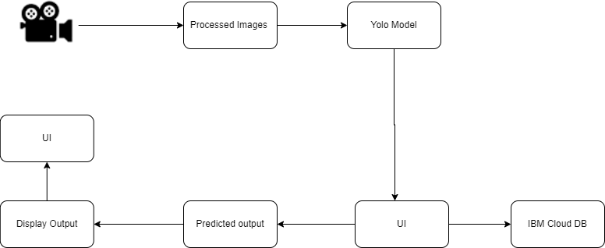

Table-1 : Components & Technologies:

|  |  |  |  |
| --- | --- | --- | --- |
| **S.No** | **Component** | **Description** | **Technology** |
| 1. | User Interface | How user interacts with application e.g. Web UI, Mobile App, Chatbot etc. | HTML, CSS, JavaScript / React JS etc. |
| 2. | Application Logic-1 | The data of the users will be stored in the data base. | MySQL, NoSQL. |
| 3. | Application Logic-2 | The Machine learning model should be trained. | CNN |
| 4. | Application Logic-3 | The CNN Algorithm will classify the uploaded images of the user. | Python |
| 5. | Database | Data Type, Configurations etc. | MySQL, NoSQL, etc. |
| 6. | Cloud Database | Database Service on Cloud | IBM DB2, IBM Cloudant etc. |
| 7. | File Storage | File storage requirements | Local Filesystem |
| 8. | Machine Learning Model | Training and Testing | Convolution Neural Network |

Table-2: Application Characteristics:

|  |  |  |  |
| --- | --- | --- | --- |
| **S.No** | **Characteristics** | **Description** | **Technology** |
| 1. | Open-Source Frameworks | Keras designed to enable fast experimentation  with deep neural networks, it focuses on being user-friendly, modular, and extensible | Keras |
| 2. | Security Implementations | Encryption is a mathematical tool that allows for encryption of data, ensuring privacy while at the  same time, allowing computations to be performed on the encrypted data. | e.g. SHA-256, Encryptions, IAM Controls, OWASP etc. |
| 3. | Scalable Architecture | Performance will be good even with the higher user traffic | Django or Flask |

|  |  |  |  |
| --- | --- | --- | --- |
| **S.No** | **Characteristics** | **Description** | **Technology** |
| 4. | Availability | With good system all users can access it. | Django or Flask |
| 5. | Performance | With greater accuracy, the performance is high | NeoLoad |